# Oxidation and Reduction Basic Summary

## Early Definitions

* Reactions in which oxygen was a reactant were described as [oxidation](http://lightbook.pearsonplaces.com.au/CH12_WA/units/CH12_WA-U03/chapters/CH12_WA-U03-06/modules/CH12_WA-U03-06-01/pages/Psec02012015074419362715/topics/Tsec04282015133719067603#sec04282015112838336251) reactions
* Reactions in which metals were extracted from compounds were described as reduction reactions. These usually involved the loss of oxygen.

This would have been classified as an oxidation reaction

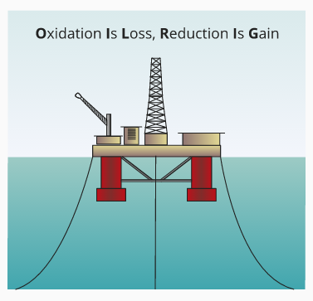2HgO(S)🡪 2Hg (l) + O2 (g)

This would have been classified as a reduction reaction

## Modern Definitions

* Oxidation is defined as the **loss of electrons**.
* Reduction is defined as the **gain of electrons**.
* Oxidation and [reduction](http://lightbook.pearsonplaces.com.au/CH12_WA/units/CH12_WA-U03/chapters/CH12_WA-U03-06/modules/CH12_WA-U03-06-01/pages/Psec02012015074419362715/topics/Tsec04282015133719067603#sec04282015112839854307) always occur simultaneously, and the reaction is referred to as a [redox reaction](http://lightbook.pearsonplaces.com.au/CH12_WA/units/CH12_WA-U03/chapters/CH12_WA-U03-06/modules/CH12_WA-U03-06-01/pages/Psec02012015074419362715/topics/Tsec04282015133719067603#sec04282015112839443320) (reduction–oxidation reaction).

(redox)

(electrons are transferred from the magnesium to the oxygen)

* There is no overall loss of electrons, but a transfer of electrons from one atom to another.
* Redox reactions are often represented by using **half equations**. One for the substance oxidised and one for the substance reduced.

(oxidation)

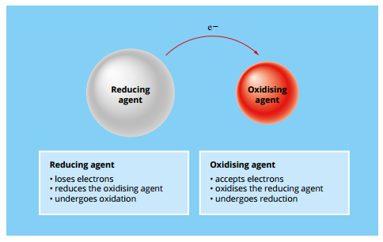(reduction)

## Oxidising Agents and Reducing Agents

* An oxidising agent (oxidant) enables or causes another chemical to be oxidised (the substance reduced).
* A reducing agent (reductant) enables or causes another chemical to be reduced (the substance oxidised)
* Redox reactions always involve an oxidising agent and a reducing agent that react together.

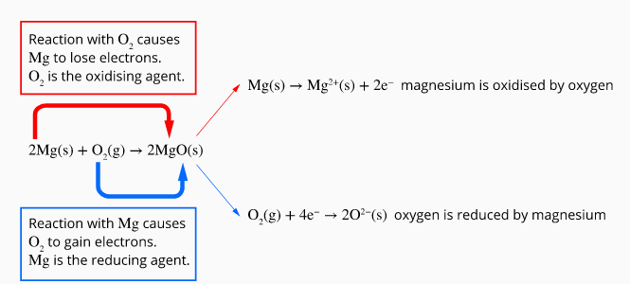

## Oxidation Numbers (States)

* Oxidation numbers are a tool that can be used to determine if a reaction is a redox reaction and identify which substances have been oxidised or reduced. Oxidation numbers are hypothetical and have no physical meaning.
* [Many elements](http://lightbook.pearsonplaces.com.au/CH12_WA/units/CH12_WA-U03/chapters/CH12_WA-U03-06/modules/CH12_WA-U03-06-02/pages/Psec01312015055243664122/topics/Tsec04282015140340773870#sec04282015112840465701) can form compounds with a variety of different oxidation numbers (or oxidation states).
* Oxidation numbers are assigned to each element involved in a reaction, based on a set of rules (see table below)

## Using Oxidation Numbers

During a redox reaction

* Oxidation involves an **increase in oxidation number**
* Reduction involves a **decrease in oxidation number**

Oxidation numbers allow the identification of which substances were oxidised and reduced.

Magnesium increase from 0 to +2 and is therefore oxidised

Oxygen decreases from 0 to -2 and is therefore reduced

## Oxidation State Rules

The following rules can be used to determine the oxidation sate of an element

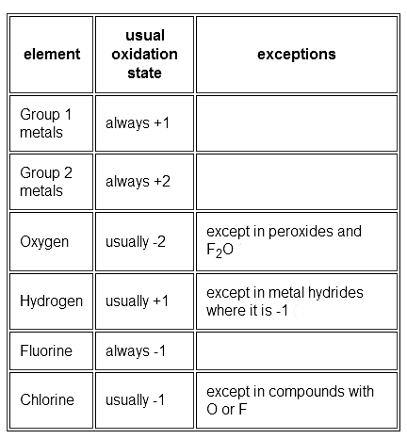

* The sum of the oxidation numbers in a neutral compound is zero, 0.
* The sum of the oxidation numbers in an ion is equal to its charge